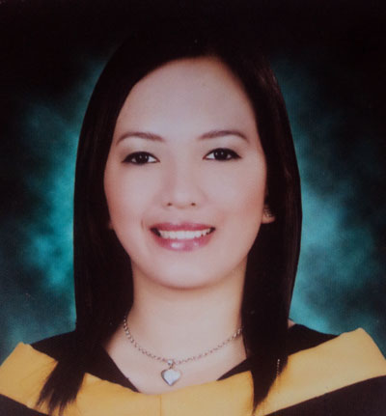**MARICAR P. ETULLE**

137 BF Ramos Street, Cebu City

Cell no. 09235951772

E-mail: [mekaki18@yahoo.com](mailto:mekaki18@yahoo.com)

**JOB OBJECTIVE:** To do my entire task under my key responsibility areas with utmost honesty and composure under pressure, for the good of the company.

**PERSONAL DATA:**

**AGE :**24

**BIRTHDAY :**November 26, 1989

**BIRTHPLACE :**Gumahan Josefina Zamboanga del Sur

**NATIONALITY :**Filipino

**RELIGION**  :Iglesia ni Cristo

**GENDER :**Female

**CIVIL STATUS :**Single

**HEIGHT :**5’3’’

**WEIGHT :**46kg

**LANGUAGE :**Filipino, English, Bisaya

**EDUCATIONAL BACKGROUND**

**Elementary Education**: Josefina Central School

Gumahan Josefina Zamboanga del Sur (1996-2002)

**Secondary level**: Leonardo National High School

Gumahan Josefina Zamboanga del Sur (2002-2006)

**College level**: Misamis University

Ozamiz City (2006-2010)

**PROFESSIONAL BACKGROUND**

**Bachelor of Science in Nursing** -Misamis University, Ozamiz City

**Professional Hair Stylist -** Rose Institute of Cosmetology, Cebu City

With Certificate, including Facial

**SKILLS**

Can Speak English

Computer Literate

Hair Styles (hair rebonding, perming, coloring, haircut)

Good Therapeutic Communication

**SUMMARY OF QUALIFICATIONS**

Enthusiastic and willing to assume increased responsibility

Energetic, positive, and self motivated

Equally effective working as a team member

**Working experience:**

Customer Service Representative - V-Customer ( JESA ITC Bldg. Gen Maxilom Ave., Cebu City)

- October 2013 – January 2014

RECEPTIONIST –Enchanted Spa ( Gen. Maxilom Ave., Cebu City)

-January 2013 – July 2013

**CHARACTER REFERENCE**

**Dr.Cynthia S. Superable,ED**

Dean,College of Nursing

Misamis University

Ozamiz City

**Clint Zyril Macabinta**

ESL Teacher

QQE English

Cebu City

**Roland Labatos**

Supervisor – V-Customer

Cebu City

09323121255